Bai 1:

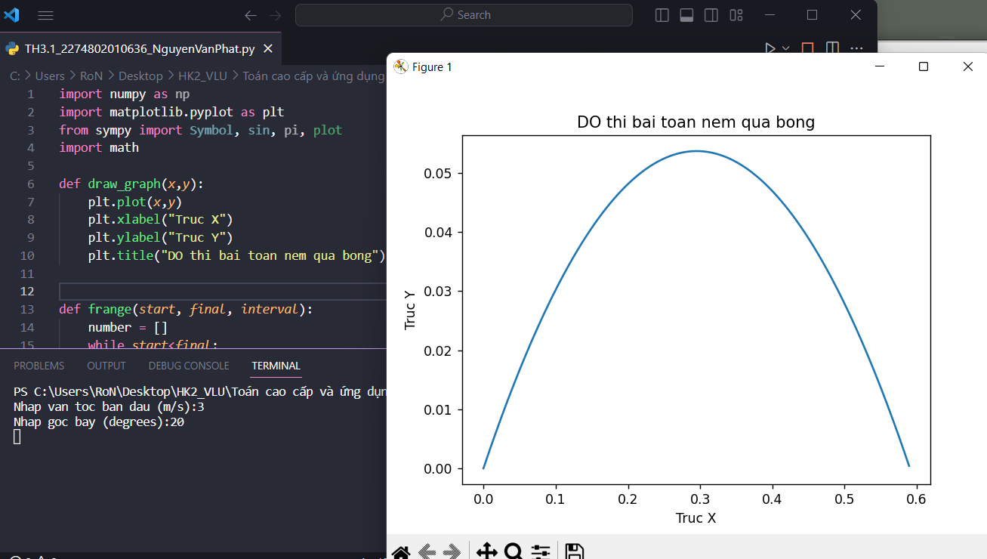

Bai 2:

